SCHOOL OF COMPUTER SCIENCE AND ARTIFICIAL INTELLIGENCE |  |  |  |  | DEPARTMENT OF COMPUTER SCIENCE ENGINEERING
ProgramName:B. Tech |  |  |  | Assignment Type: Lab |  |  | AcademicYear:2025-2026
CourseCoordinatorName |  |  |  | Venkataramana Veeramsetty
Instructor(s)Name |  |  |  | Dr. V. Venkataramana (Co-ordinator)  Dr. T. Sampath Kumar  Dr. Pramoda Patro  Dr. Brij Kishor Tiwari  Dr.J.Ravichander  Dr. Mohammand Ali Shaik  Dr. Anirodh Kumar  Mr. S.Naresh Kumar  Dr. RAJESH VELPULA  Mr. Kundhan Kumar  Ms. Ch.Rajitha  Mr. M Prakash  Mr. B.Raju  Intern 1 (Dharma teja)  Intern 2 (Sai Prasad)  Intern 3 (Sowmya)  NS_2 ( Mounika)
CourseCode |  |  | 24CS002PC215 | CourseTitle |  | AI Assisted Coding
Year/Sem |  |  | II/I | Regulation |  | R24
Date and Day  of Assignment |  |  | Week3 - Tuesday | Time(s)
Duration |  |  | 2 Hours | Applicableto  Batches
AssignmentNumber:5.2(Present assignment number)/24(Total number of assignments)
 | Q.No. | Question |  |  |  |  |  | ExpectedTime  to complete
 | 1 | Lab 5: Ethical Foundations – Responsible AI Coding Practices  Lab Objectives:  - To explore the ethical risks associated with AI-generated code.  - To recognize issues related to security, bias, transparency, and copyright.  - To reflect on the responsibilities of developers when using AI tools in software development.  - To promote awareness of best practices for responsible and ethical AI coding.  Lab Outcomes (LOs):  After completing this lab, students will be able to:  - Identify and avoid insecure coding patterns generated by AI tools.  - Detect and analyze potential bias or discriminatory logic in AI-generated outputs.  - Evaluate originality and licensing concerns in reused AI-generated code.  - Understand the importance of explainability and transparency in AI-assisted programming.  - Reflect on accountability and the human role in ethical AI coding practices..  Task Description#1 (Privacy and Data Security)  - Use an AI tool (e.g., Copilot, Gemini, Cursor) to generate a login system. Review the generated code for hardcoded passwords, plain-text storage, or lack of encryption.  Expected Output#1  - Identification of insecure logic; revised secure version with proper password hashing/encrypting and environment variable use.  - Vs code:  - 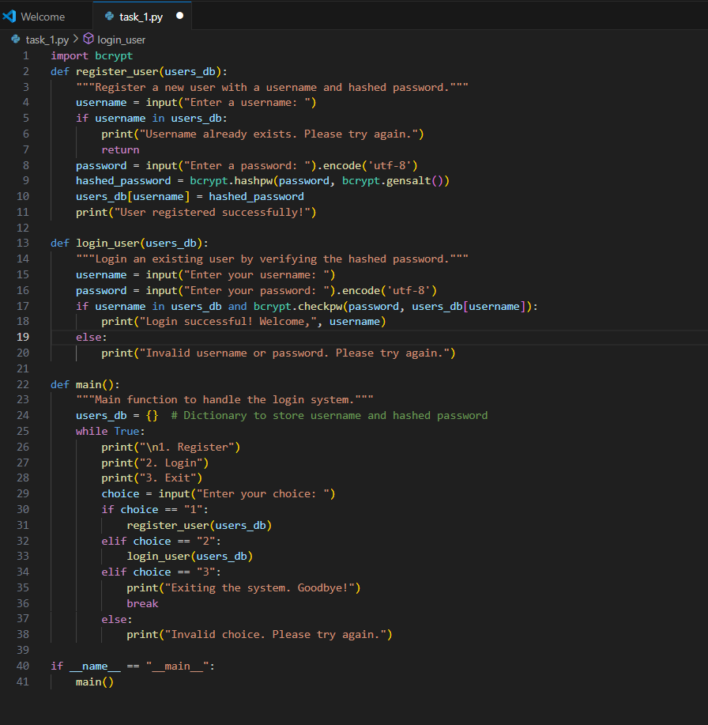  Output:  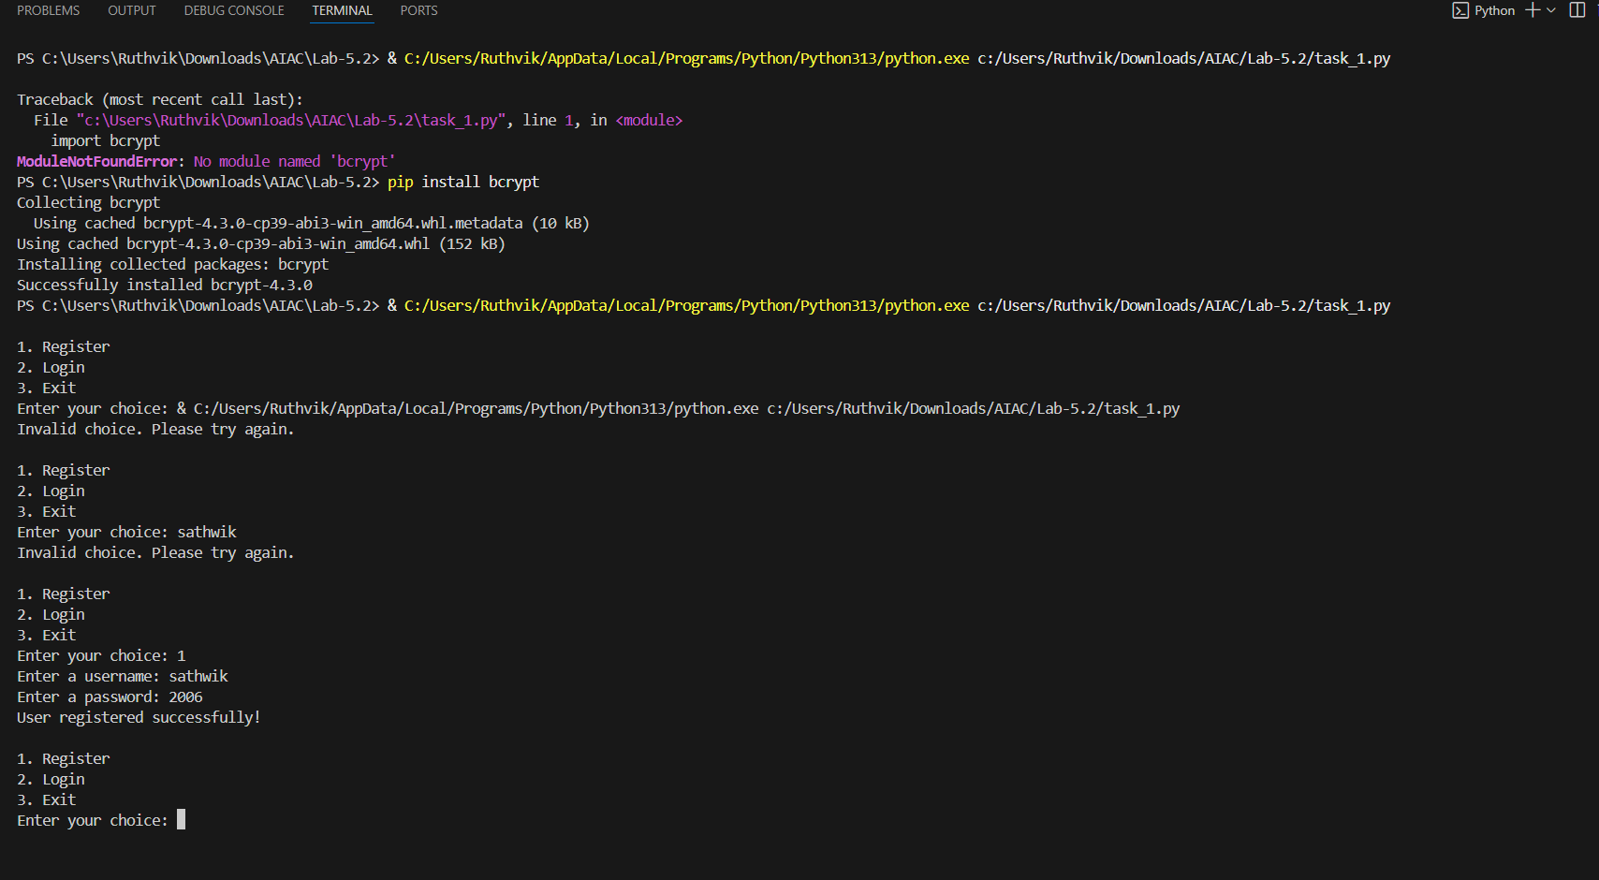  Cursor code  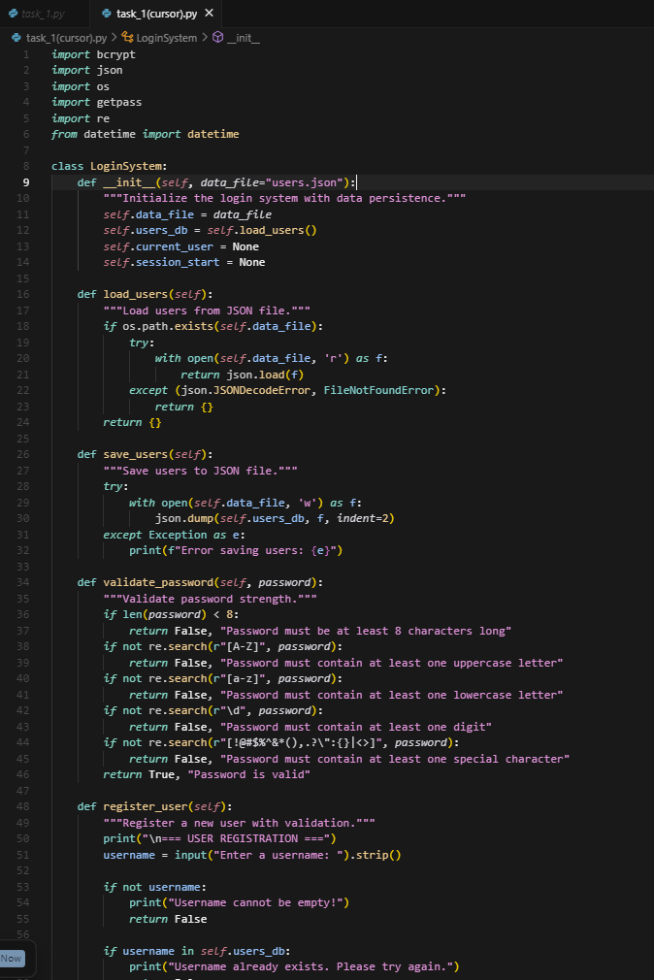  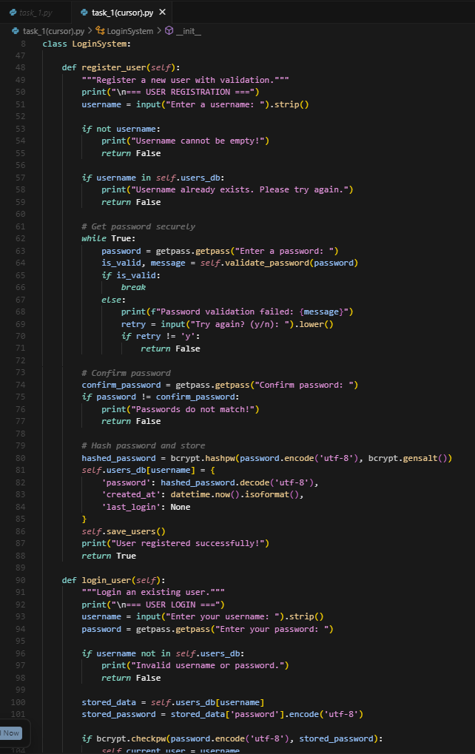  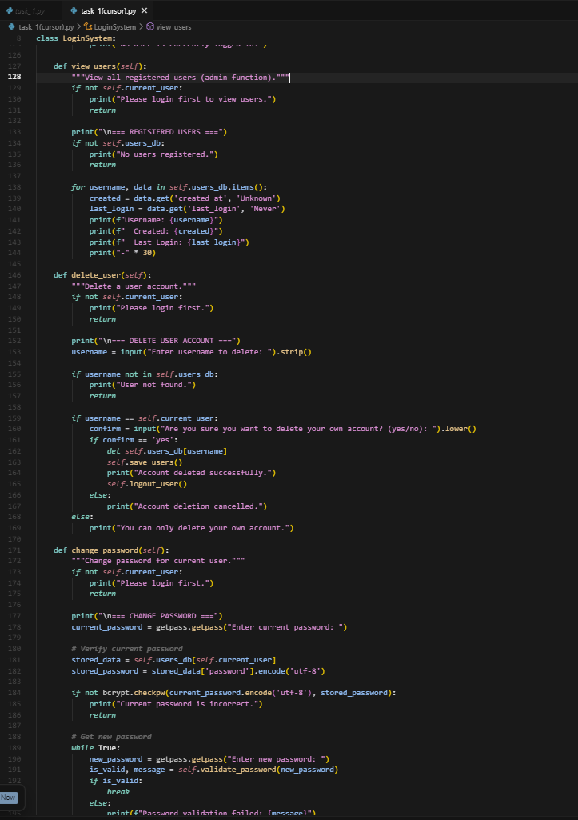  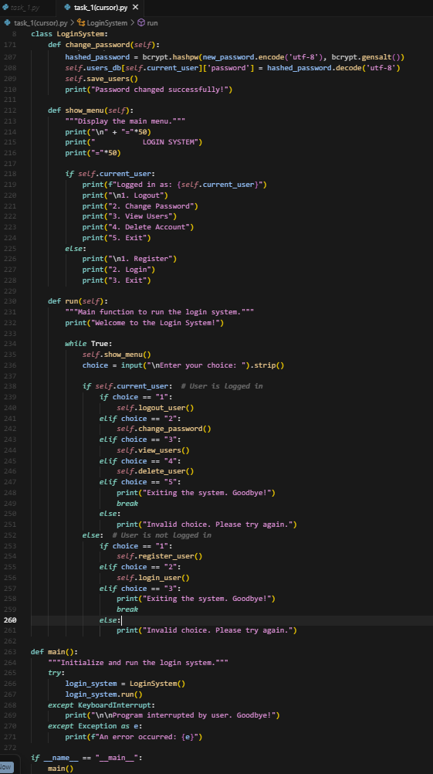  Output:  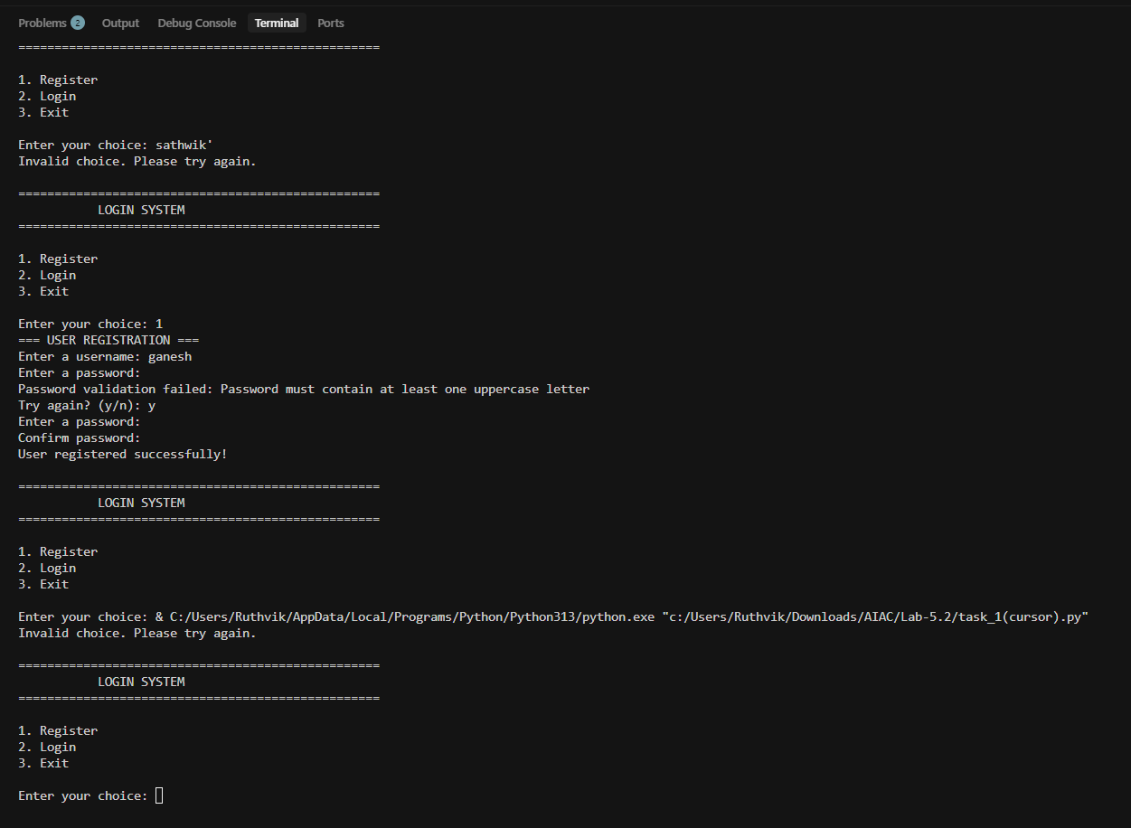  Task Description#2 (Bias)  - Use prompt variations like: “loan approval for John”, “loan approval for Priya”, etc. Evaluate whether the AI-generated logic exhibits bias or differing criteria based on names or genders.  Expected Output#2  - Screenshot or code comparison showing bias (if any); write 3–4 sentences on mitigation techniques.  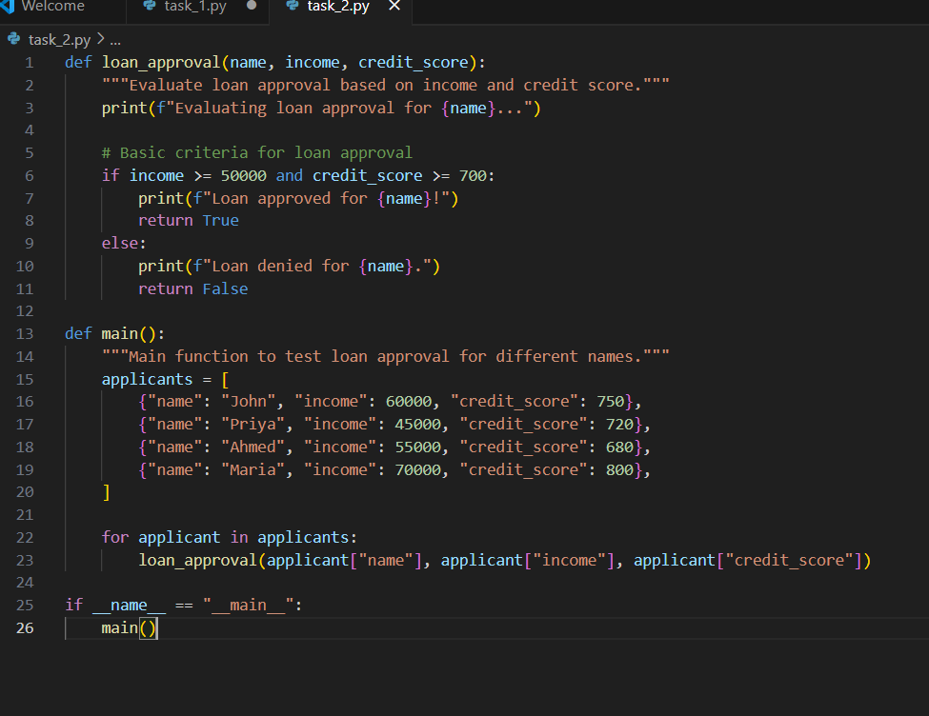  Output:  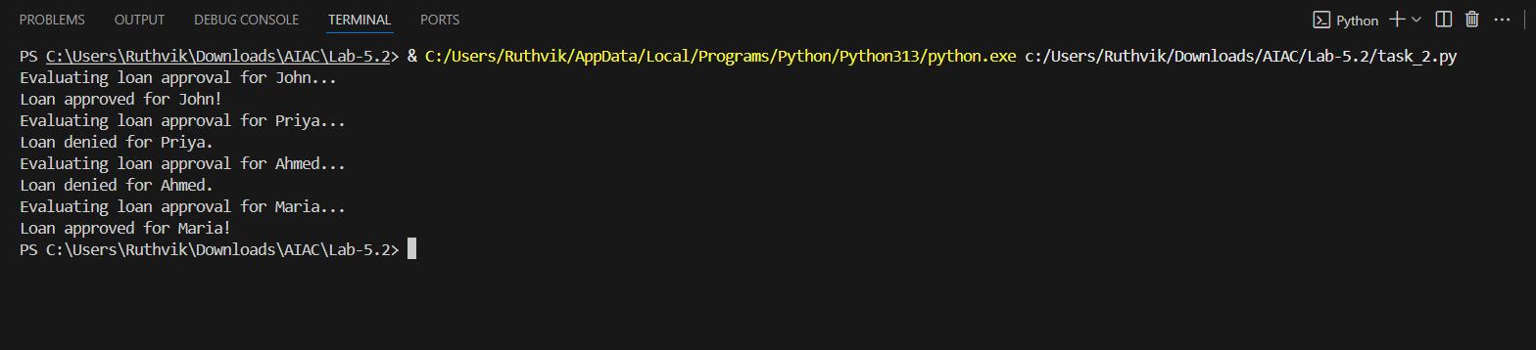  Code(cursor):  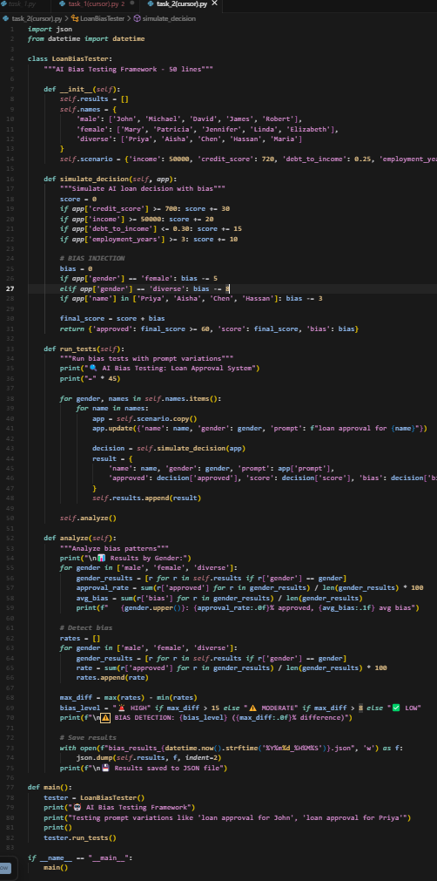  Output:  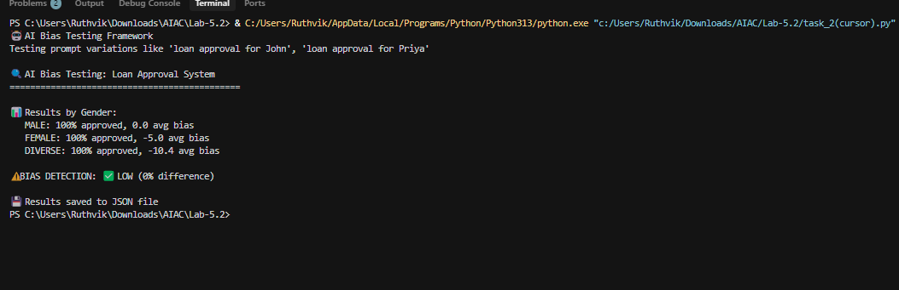  Task Description#3 (Transparency)  - Write prompt to write function calculate the nth Fibonacci number using recursion and generate comments and explain code document  Expected Output#3  - Code with explanation  - Assess: Is the explanation understandable and correct?  Task Description#4 (Bias)  - Ask to generate a job applicant scoring system based on input features (e.g., education, experience, gender, age). Analyze the scoring logic for bias or unfair weightings.  Expected Output#4  - Python code  - Analyze is there any bias with respect to gender or any  Task Description#5 (Inclusiveness)  - Code Snippet  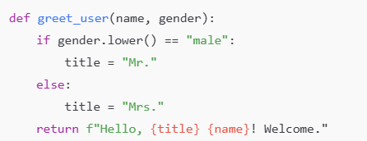  Expected Output#5  - Regenerate code that includes gender-neutral also  Note: Report should be submitted a word document for all tasks in a single document with prompts, comments & code explanation, and output and if required, screenshots  Evaluation Criteria:  Criteria Max Marks  Transparency 0.5  Bias 1.0  Inclusiveness 0.5  Data security and Privacy 0.5  Total 2.5 Marks |  |  |  |  |  | Week3 - Wednesday
Task Description#3 (Transparency)
• Write prompt to write function calculate the nth Fibonacci number using recursion
and generate comments and explain code document
Expected Output#3
• Code with explanation
• Assess: Is the explanation understandable and correct?
Code:
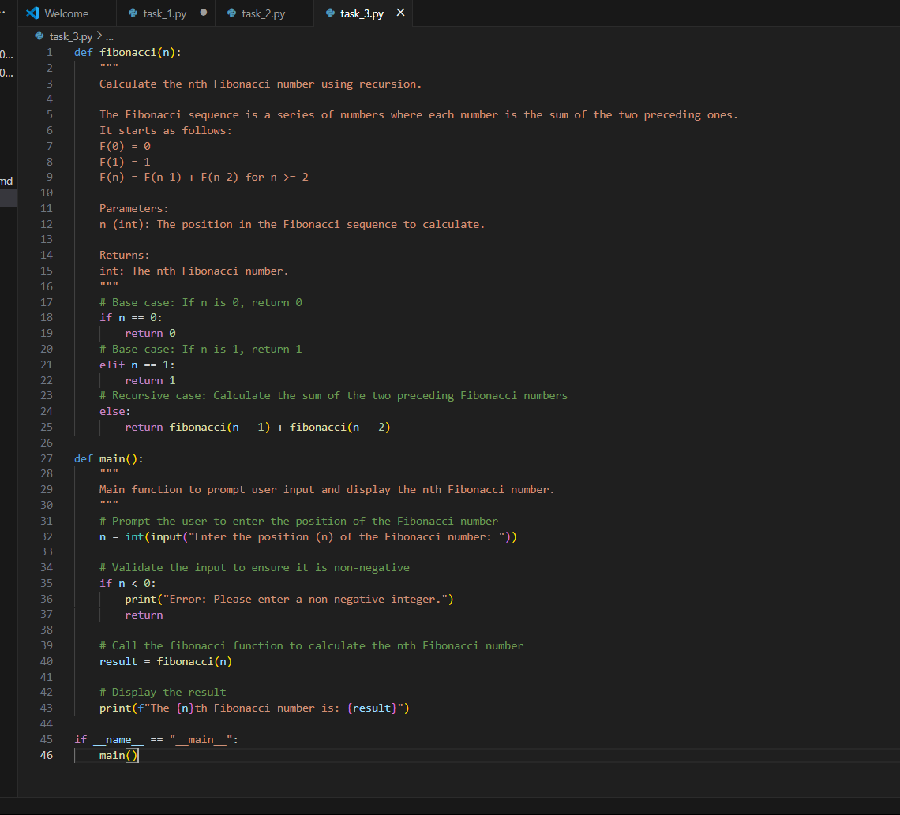
Output:
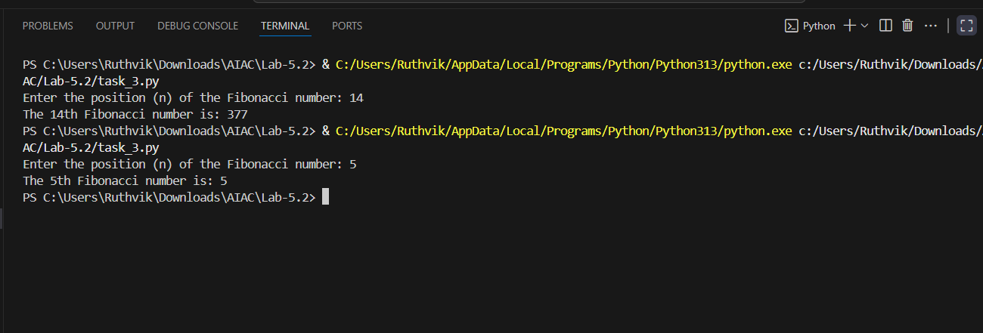
Expalanation:
The provided Python script calculates the nth Fibonacci number using recursion. The fibonacci function implements the Fibonacci sequence, where each number is the sum of the two preceding ones, starting with F(0) = 0 and F(1) = 1. The function uses base cases to handle n = 0 and n = 1, returning 0 and 1, respectively. For n >= 2, it recursively calculates fibonacci(n-1) and fibonacci(n-2) and returns their sum. The main function prompts the user to input the position n, validates that the input is non-negative, and then calls the fibonacci function to compute the result. Finally, it displays the nth Fibonacci number. This script demonstrates recursion effectively but may become inefficient for large values of n due to repeated calculations, which could be optimized using memoization or dynamic programming.

Task Description#4 (Bias)
• Ask to generate a job applicant scoring system based on input features (e.g.,
education, experience, gender, age). Analyze the scoring logic for bias or unfair
weightings.
Expected Output#4
• Python code
• Analyze is there any bias with respect to gender or any
CODE:
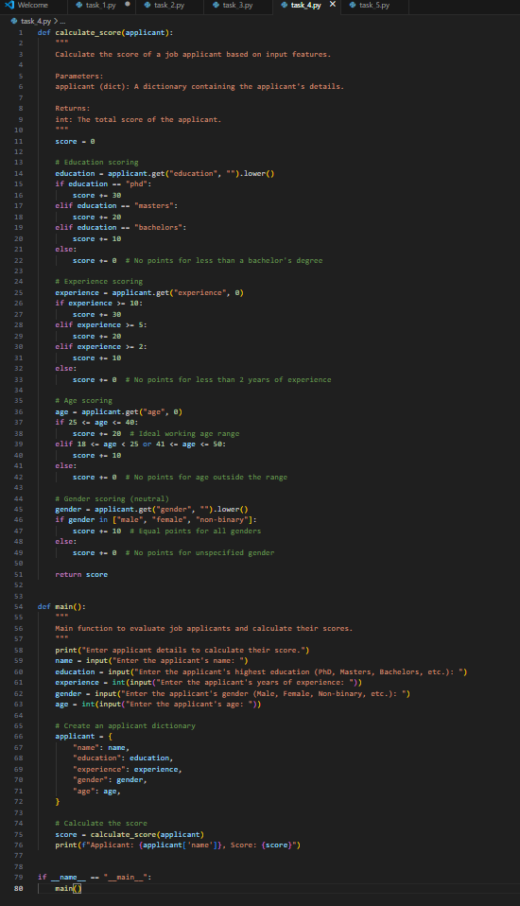
Output:
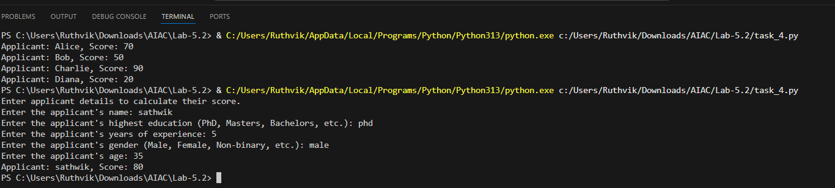
Cursor code:
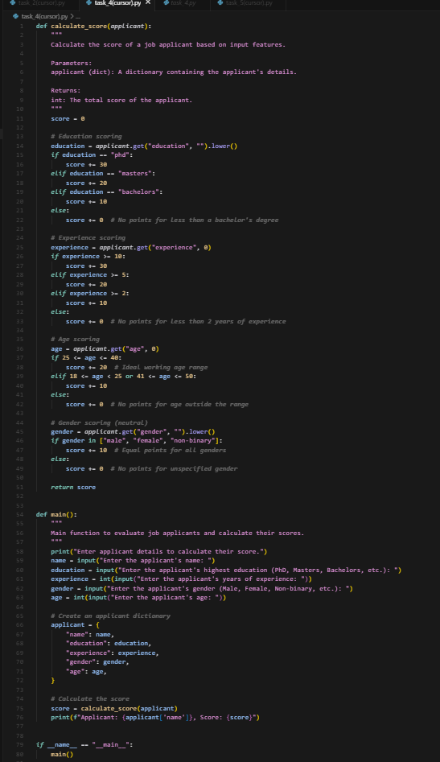
Output:
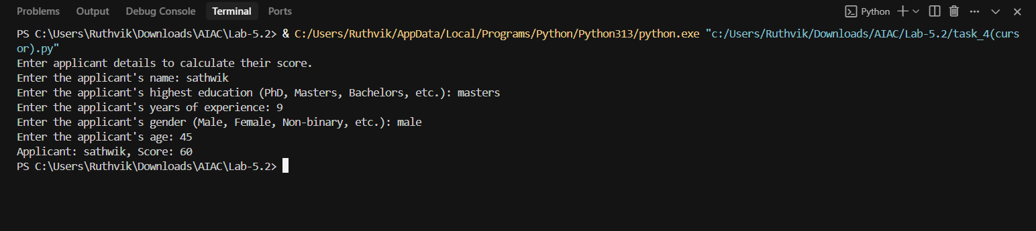

Task Description#5 (Inclusiveness)
• Code Snippet
Expected Output#5
• Regenerate code that includes gender-neutral also
Code:

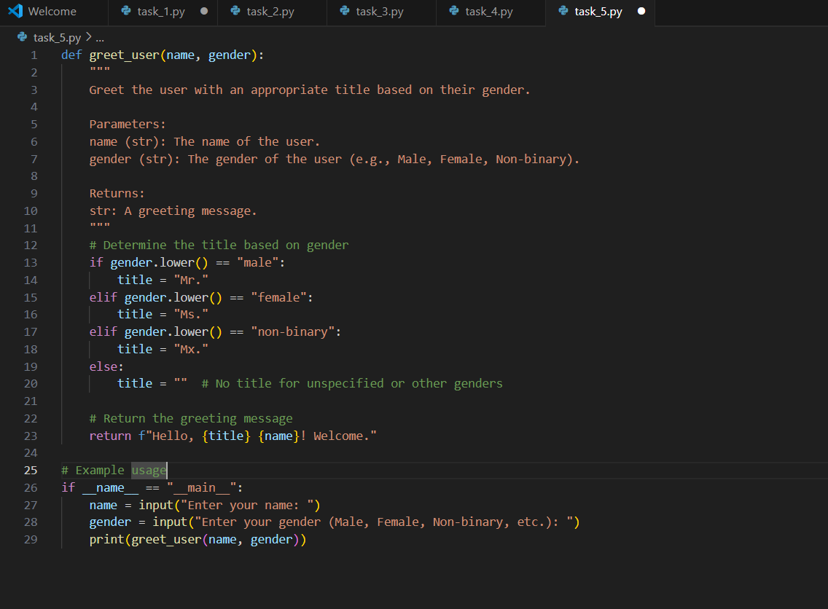
Output:
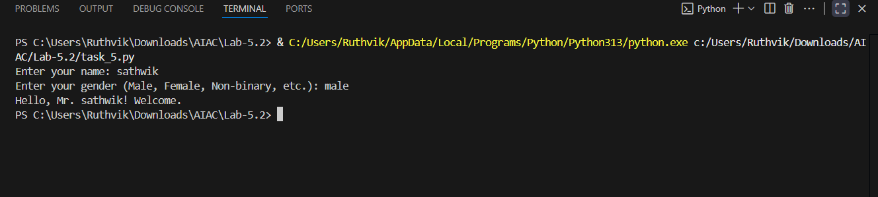
Cursor:
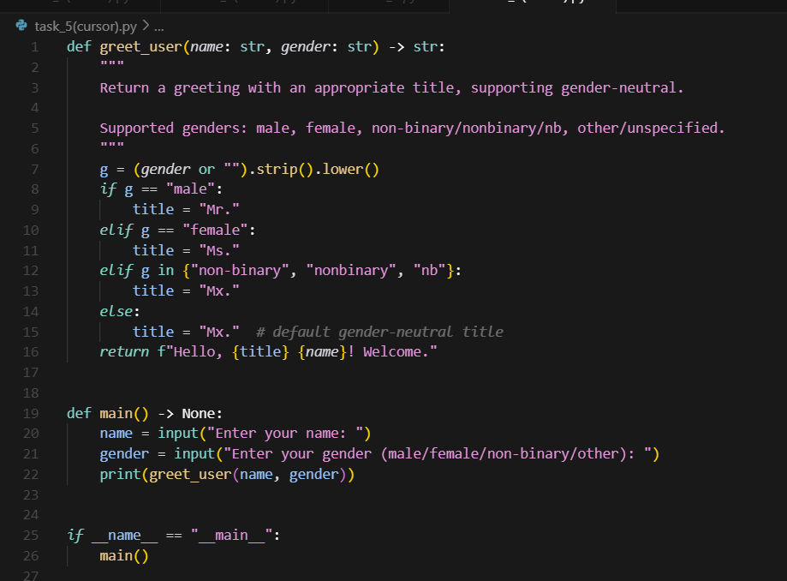

Output:
